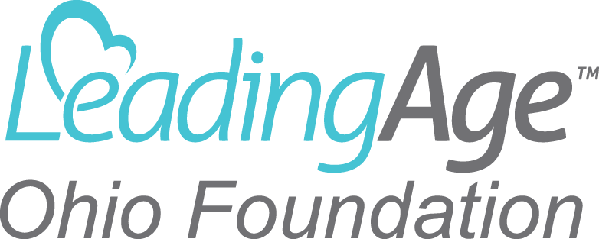

SPECIFIC CRITERIA FOR A LEADINGAGE OHIO LEADERSHIP ACADEMY SCHOLARSHIP

The LeadingAge Ohio Foundation has the responsibility for ensuring that scholarship winners represent the best in the spirit of not-for-profit aging services. Scholarships will be awarded based upon the following criteria: need, experience, diversity, demonstrated leadership and commitment to the field of aging services, housing and hospice fields.

You have applied to be a participant in the LeadingAge Ohio Leadership Academy. We will use the Academy application information as the basis of awarding a scholarship. Also, we will need additional information around financial needs since we have limited funds and can only award a certain number of scholarships. Please complete the scholarship application and return it by November 2, 2018.

The criteria below will be used as our guide in awarding a scholarship:

Commitment to the field of aging services and leadership – (40 points)
- Candidates who have demonstrated that they value membership in LeadingAge, LeadingAge Ohio and other aging service professional networks with their support of, availability for and/or participation in:
  - The advancement of advocacy. Examples could include but are not limited to:
    - Committee participation
    - Involvement in policy leader education and relationship development
    - Testimony, letters, visits and other direct activities to advocate for public policy.
  - Demonstration of a commitment to quality through such activities as:
    - Campus participation in programs such as Quality First and/or Advancing Excellence.
    - Campus has a reputation for quality of care and services through CMS Five star ratings, Ohio Department of Health or other survey agency outcomes and/or peer review organizations.
  - State and national education that supports a not-for-profit’s mission. Examples might include:
    - Participation in professional development opportunities.
    - Speaker or faculty at educational offerings.
    - Participation in internship or mentorship programs (ie: AIT).
  - Participation in leadership at local, state and/or national level such as through LeadingAge Ohio or other professional network committees, regional programs, and employee recognition programs. Actively supports campus recognition of employees, volunteers or best practices.

Diversity (20 points)

- Candidates who represent diversity. Examples include: candidates whose scope of work has a breadth of service (i.e., more than one area of aging services); candidates whose ethnic background is racially/culturally diverse; candidates whose background or training may not be in management.
Need (20 points)
- Candidates who have demonstrated a need for tuition assistance. For example, candidates who do not have employee assistance in further education or where the employer will only reimburse up to a certain amount of tuition because of cap on expenses. The scholarship committee believes that it is important for the employer to commit to helping the employee in his or her leadership development.
Community Involvement (20 points)
- Candidates who are involved in their respective communities. Examples of this include: participation in Rotary, involvement in community events, public education on aging issues and services, etc.

